**Lab Task 5**

**Fundamentals of Programming**

Instructor: Sir Affan

Name: Syed Muhammad Ali Akbar

CMS: 477723

**Code 1:**

//Task 1

# include <iostream>

using namespace std;

int main()

{

    int x=1;

    do

    {

        cout<<"Enter a number: ";

        cin>>x;

    }while(x>0);

    return 0;

}

**Output 1:**

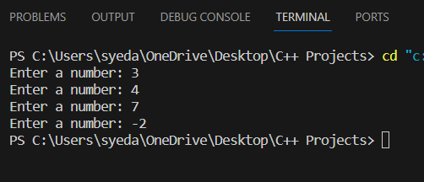

**Code 2:**

//Task 2

#include <iostream>

using namespace std;

int main()

{

    double num1;

    char opr;

    double num2;

    char option;

    do

    {

        cout<<"Enter first Number:  "<<endl;

        cin>>num1;

        cout<<"Enter operation: "<<endl;

        cin>>opr;

        cout<<"Enter second number"<<endl;

        cin>>num2;

        switch(opr)

        {

            case '*':

               cout<<num1<<" * "<<num2<<" = "<<num1*num2<<endl;

               break;

            case '/':

               cout<<num1<<" / "<<num2<<" = "<<num1/num2<<endl;

               break;

            case '+':

               cout<<num1<<" + "<<num2<<" = "<<num1+num2<<endl;

               break;

            case '-':

               cout<<num1<<" - "<<num2<<" = "<<num1-num2<<endl;

               break;

            default:

               cout<<"Enter a valid operator: "<<endl;

        }

        cout<<"Do you want to continue? Enter 'y' for yes and 'n' for no  "<<endl;

        cin>>option;

    }while(option=='y');

    return 0;

}

**Output 2:**

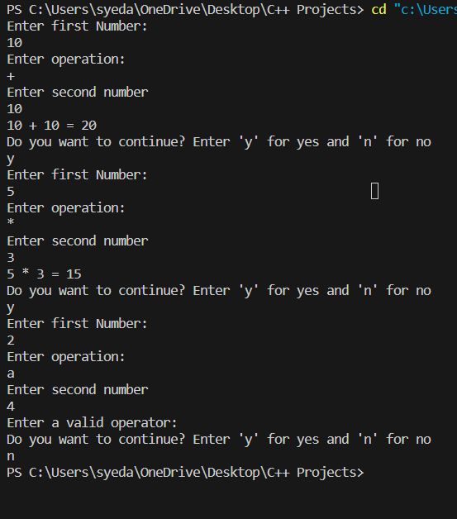

**Code 3(a) :**

//Task 3(a)

# include <iostream>

using namespace std;

int main()

{

    int num=2;

    int sum=0;

    while (num>=2&&num<=100)

    {

        if(num%2==0)

        {

            sum+=num;

        }

        num++;

    }

    cout<<"The sum of all even numbers between 2 and 100 (inclusive) is  "<<sum<<endl;

}

**Output 3(a) :**

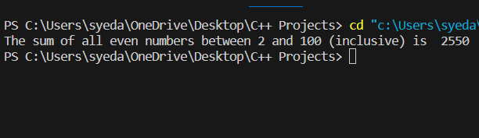

**Code 3(b) :**

//Task 3(b)

# include <iostream>

using namespace std;

int main()

{

    int num=1;

    int sqnum;

    int sum=0;

    while (num>=1&&num<=10)

    {

        sqnum=num*num;

        sum+=sqnum;

        num++;

    }

    cout<<"The sum of all square numbers between 1 and 100 (inclusive) is  "<<sum<<endl;

}

**Output 3(b) :**

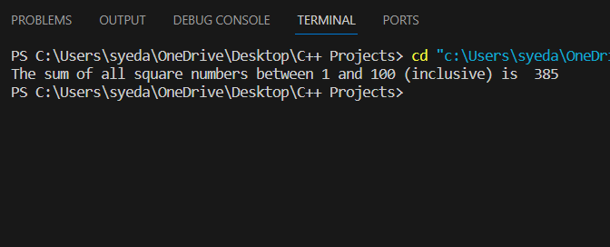

**Code 4(a) :**

//Task 4(a)

# include <iostream>

# include <cmath>

using namespace std;

int main()

{

    int exp=0;

    while(exp>=0&&exp<=20)

    {

        cout<<pow(2,exp)<<endl;

        exp++;

    }

    return 0;

}

**Output 4(a) :**

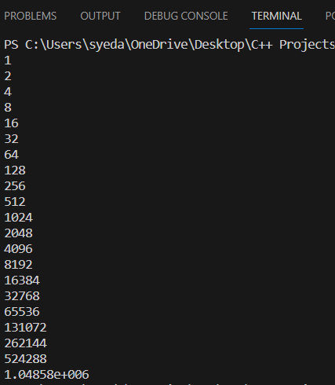

**Code 4(b) :**

//Task 4(b)

# include <iostream>

# include <cmath>

using namespace std;

int main()

{

    int a;

    cout<<"Enter number a: "<<endl;

    cin>>a;

    int b;

    cout<<"Enter number b: "<<endl;

    cin>>b;

    int num=a;

    int sum=0;

    while(num<=b)

    {

        if(num%2!=0)

        {

            sum+=num;

            num++;

        }

        num++;

    }

    cout<<"Sum of all odd numbers between a and b(inclusive) is "<<sum<<endl;

    return 0;

}

**Output 4(b) :**

